June 26, 2017

TO: Prof. Jeremy Roberts

FROM: Dr. Mark Harrison

SUBJECT: Radiation Hardness of Silicon Photomultipliers in Hornyak-type Applications

# Introduction

The Transient Reactor Test Facility (TREAT) reactor utilizes a fast-neutron hodoscope focused on a small region within the core of the reactor to observe samples during irradiation. The original detecting elements of the hodoscope were variations of the Hornyak button, more specifically a rectangular parallelepiped region of ZnS:Ag scintillator homogeneously mixed within a lucite matrix optically coupled to lucite light guides completing the cylindrical prism necessary to matching the cross-section of the mated photomultiplier tube (PMT). The original PMTs were Phillips XP1110 10-stage ¾ in diameter photomultipliers which used bialkali photocathodes well-matched to the emissions of ZnS:Ag.

Silicon photomultipliers (SiPMs), over the last decade, have achieved considerable advancements and were previously considered (see memo Oct. 27) to offer some advantages over PMTs in this particular application in the TREAT reactor. For all their advantages, though, it was realized that their hardness to fission-spectrum neutron irradiation was relatively unknown. As such, a study was conducted to determine how SiPMs would react to exposure to fission-spectrum neutron fluxes.

# Literature

Two previously published studies were found in the literature regarding the impact neutron irradiation would have on SiPMs [1,2]. However, the first study [1] irradiated the devices with a white spectrum of neutrons while the second study [2] used only cold neutrons. While the findings in both of these articles are applicable here, they do not directly correlate to the application. The spectrum of neutrons expected in the hodoscope beamlines is much harder, more closely resembling that of a fission neutron energy spectrum. Given the various damage mechanisms that silicon is known to exhibit under neutron irradiation and their various energies necessary to occur, it was deemed important to determine experimentally the damage that fission-spectrum neutrons would have on SiPMs as opposed to relying entirely on previous studies.

# Experiment

Two models of SiPMs were obtained from SensL; those being one of the C-Series and one of the J-Series. Both SiPMs were of the 6mm × 6mm form factor with 35 µm microcells mounted to evaluation boards. Three-dimensional (3D) printed mounts were designed and printed for two purposes. The first purpose was to reliably orient and hold a small LaBr3:Ce crystal tightly coupled to a 10 mm Ø × 10 mm long quartz cylinder light guide onto each SiPM board. This mount ensured that the test scintillator could be remounted many times with little variation between optical couplings. The second mount was designed to hold both boards precisely 1mm from the center of a 252Cf source to ensure fluence calculations would be accurate.

A series of measurements were done at each step in the experiment. For each measurement series, a set of at least six gamma-ray spectra were collected in which the LaBr3:Ce crystal was mounted to the SiPM and a 137Cs source placed nearby, a long background count in which the LaBr3:Ce crystal was mounted to the SiPM but no source was present and finally a dark spectrum in which the LaBr3:Ce was removed and the SiPM held in a light tight enclosure. The gamma spectra were collected for a sufficiently long time as to obtain a mature full energy peak from which its centroid and FWHM could be measured, typically 180-300 s live time counts. These were repeated six times to ensure a reasonable estimate of the average centroid and average FWHM could be obtained, since optical coupling efficiencies did vary somewhat between measurements. Background spectra were typically collected for at least 600 s while dark spectra were collected for 600 s each. For the gamma and background spectra, the LLD was set just above the electronic noise. The LLD was then lowered as far as possible for the dark spectra measurements. Lowering of the LLD for the dark counts was limited by dead time. Essentially, as much of each dark spectrum was collected as was permitted by dead time.

Each SiPM was initially measured in the manner described in the previous paragraph. Then they were placed in their irradiation mount and exposed to a 9 µg 252Cf source for the pre-computed amount of time necessary to reach the next fluence stopping point. Table 1 lists the fluence intervals chosen as well as the exposure time needed to irradiate the SiPMs from the previous stopping point to the next. Note that the fluence stopping points correspond to a logarithmic progression from 107 to 108.4 in steps of 0.2 of the exponent. This yields evenly spaced points in a logarithmically scaled axis plot.

**Table 1.** Irradiation times and fluence stopping points.

|  |  |
| --- | --- |
| **Dose**  **(n/cm2)** | **Time**  **Irradiated** |
| 107 | 59.6 min |
| 1.58x107 | 34.9 min |
| 2.51x107 | 55.3 min |
| 3.98x107 | 1 hr 27.6 min |
| 6.31x107 | 2 hr 18.9 min |
| 108 | 3 hr 40.1 min |
| 1.58x108 | 5 hr 48.8 min |
| 3.98x108 | 23 hr 49.1 min |

# Results

It was generally found that dark noise increased with increasing fluence as is shown in Figs. 1 and 2 below. As can be seen, the dark spectra increased significantly, out to approximately channel 100 for the C-Series and channel 70 for the J-Series.

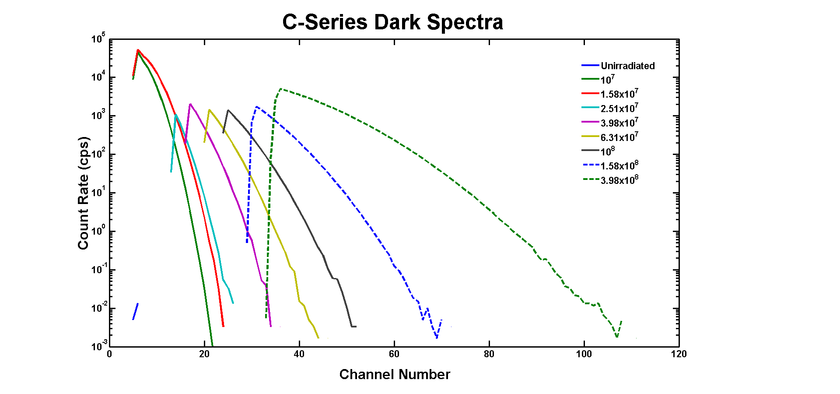

**Figure 1**. Dark spectra for the C-Series SiPM.

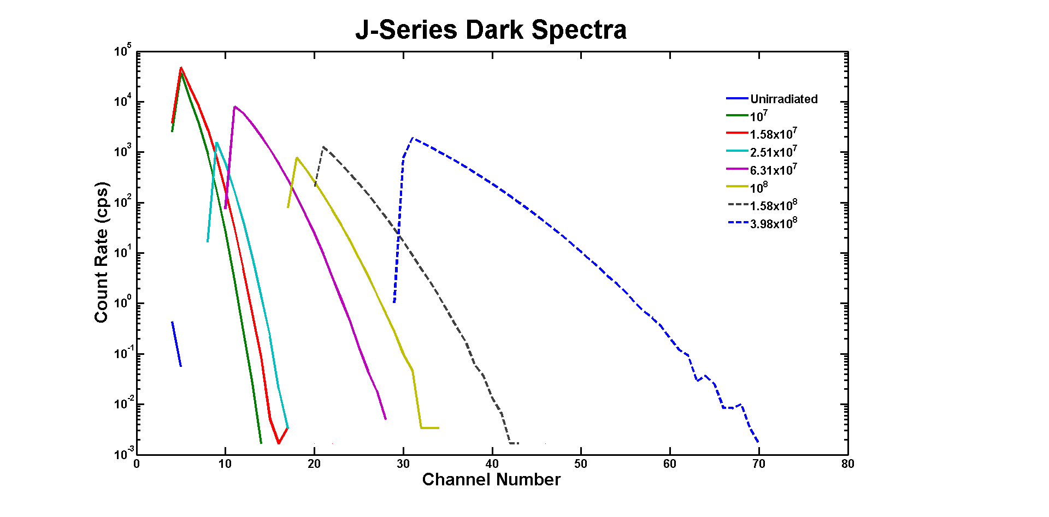

**Figure 2**. Dark spectra for the J-Series SiPM.

Correspondingly, a decrease in the full energy peak centroid was observed for both SiPMs as is plotted in Figs. 3 and 4 below. This decrease appears to follow roughly linearly with respect to fluence. In both plots, the dashed blue line is the linear curve of best fit (curvature seen here is due to the semi-logarithmic plot style).

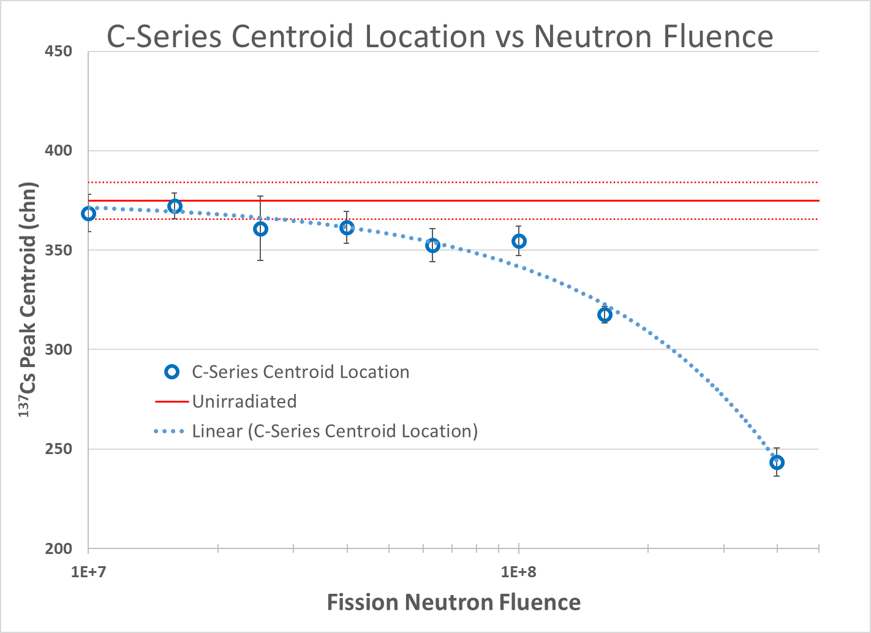

**Figure** **3**. Full energy peak (137Cs, 662keV) centroid as a function of fluence for the C-Series SiPM.

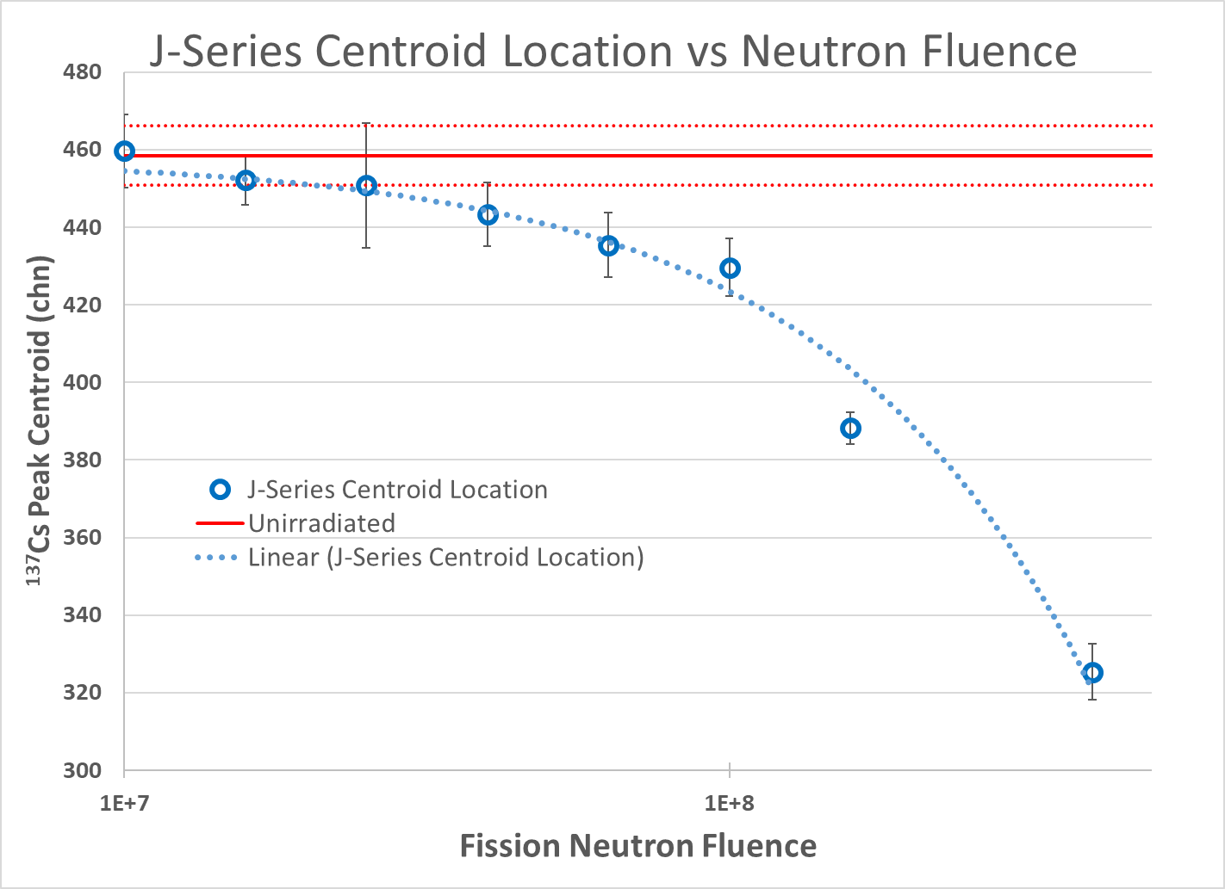

**Figure** **4**. Full energy peak (137Cs, 662keV) centroid as a function of fluence for the J-Series SiPM.

Finally, it was also observed that the FWHM of the full energy peak degraded with increasing fluence as is shown in Figs. 5 and 6.

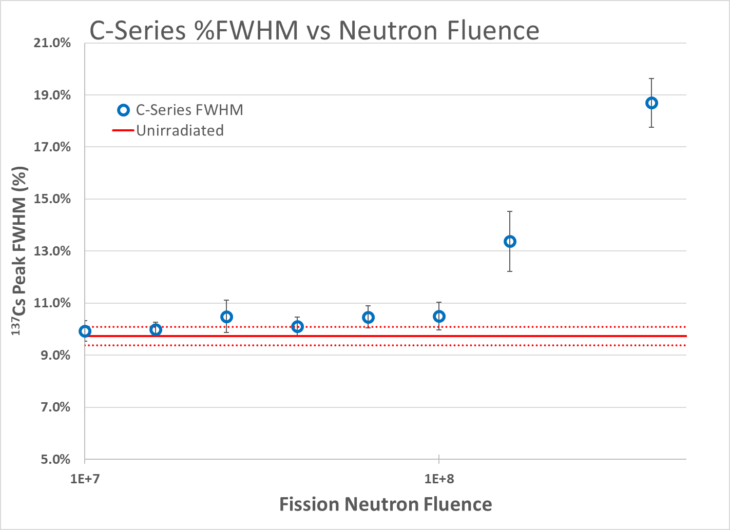

**Figure** **5**. Full energy peak (137Cs, 662keV) energy resolution as a function of fluence for the C-Series SiPM.

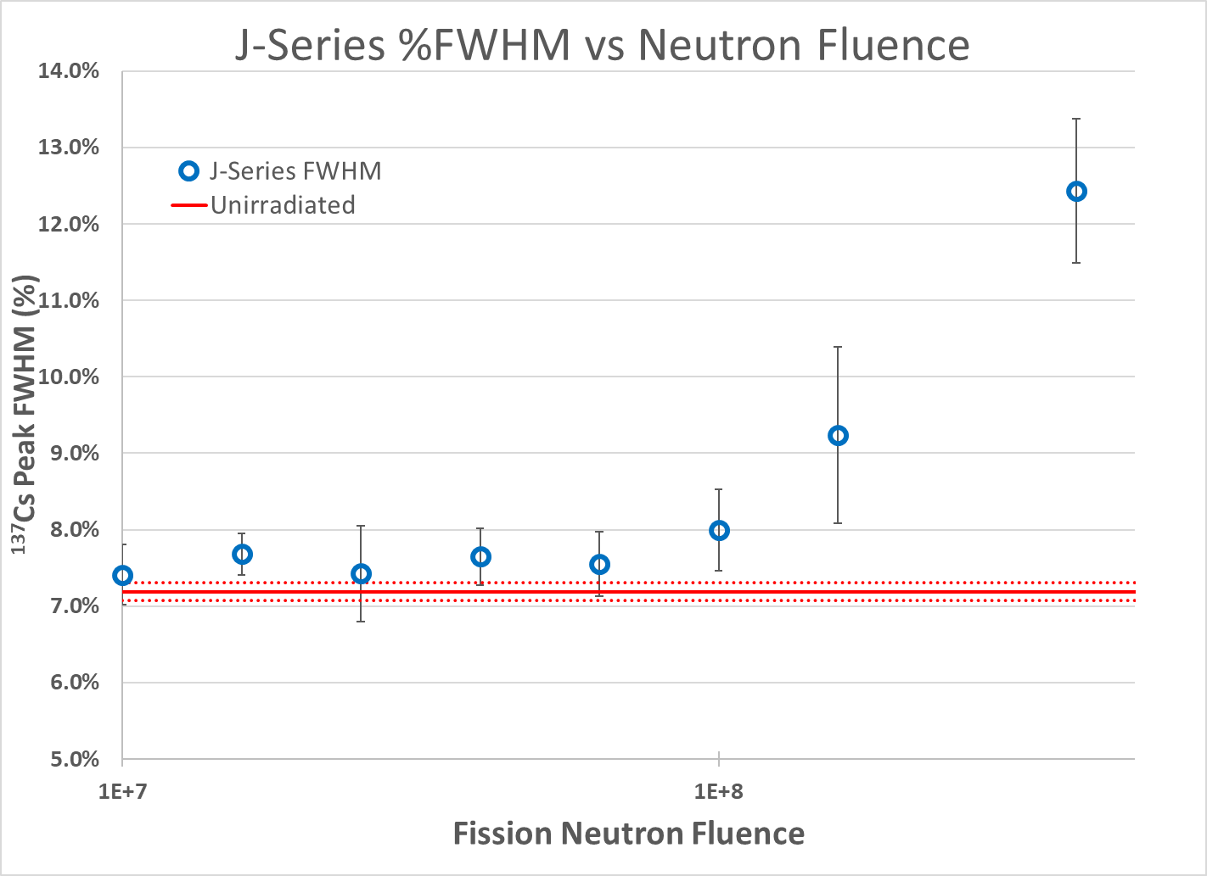

**Figure** **6**. Full energy peak (137Cs, 662keV) energy resolution as a function of fluence for the J-Series SiPM.

# Conclusions

The recorded data indicates that the SiPMs do indeed experience performance degradation with respect to fission neutron fluence. To determine how severe this damage is, compare the spectra shown in Fig. 7. Fig. 7 plots the 137Cs spectrum of the J-Series SiPM at zero fluence against the spectrum obtained with a traditional Hornyak button (as developed for the TREAT hodoscope) exposed to AmBe neutrons/gammas and the dark spectrum collected from the J-Series SiPM after 3.98×108 n/cm2. As can be noted, the dark spectrum reaches out to roughly channel 70 and thus for reliable operation it would be necessary to set the counting LLD at approximately channel 70. Unfortunately, a preponderance of the counts recorded with the Hornyak button lie below channel 70, thus the LLD placement at channel 70 would deleteriously effect detection efficiency to a significant degree. Summing counts in the AmBe spectrum, the Hornyak averaged 86.2 cps with the LLD placed at channel 5. Moving the LLD to channel 70 would decrease the count rate to ~2.4 cps. This count rate decrease corresponds to a loss of approximately 97.3% in the efficiency of the Hornyak, i.e. the Hornyak efficiency which is known to be roughly 0.2% would become 0.0055%.

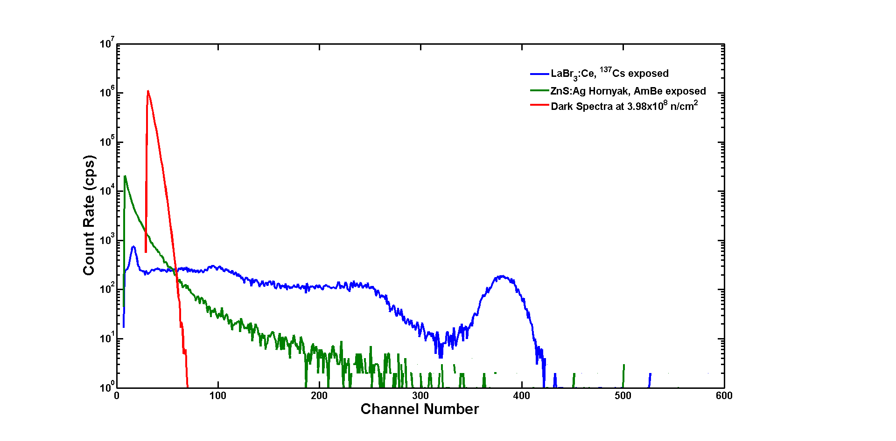

**Figure 7.** Pulse height spectra recorded using the J-Series SiPM.

Of course, it is known that a single pulse of the TREAT reactor would not irradiate the SiPMs to 3.98×108 n/cm2. Instead, full exposure in the beam would yield a fluence of something near 108 n/cm2. Moving the SiPM out of the beam would curtail damage to something less than that observed here for 108 n/cm2. Nevertheless, moving the LLD to just channel 20, would cause efficiency to decrease to 19.3 cps, less than ¼ of the count rate without damage, i.e. Hornyak efficiency would change from 0.2% to 0.045%.

The impact that neutron damage has on SiPMs indicates that these devices are not well suited to the TREAT hodoscope application and alternative technologies should be investigated.

# References

[1] Andreotti, M., W. Baldini, R. Calabrese, et. al., “Silicon Photo-Multiplier Radiation Hardness Tests with a White Neutron Beam”, 2013 3rd Annual Advancements in Nuclear Instrumentation, Measurement Methods and Their Applications (ANIMMA), IEEE, June 23-27, 2013.

[2] Durini, D., C. Degenhardt, H. Rongen, et. al., “Evaluation of the Dark Signal Performance of Different SiPM-Technologies under Irradiation with Cold Neutrons”, *Nucl. Instrum. Meth. A* **835** (2016) 99-109.